# High Level Summary

The laser system consists of a seed laser, an amplifier, a laser isolator, and two thermoelectric coolers to keep the lasers cool. The seed laser turns on and is active all the time and the amplifier, also known as the TA or tapered amplifier, pulses in sync with the camera. Each of these devices, with the exclusion of the isolator, has a control module. On newer versions of the system the isolator is built in to the laser components. The Multifunction Laser Board, or MLB/MLIB powers the two laser controllers and controls the thermoelectric coolers. The MLIB monitors the lasers and shuts them down if various parameters are breached. The MLIB also connects to a small board that is mounted atop the TA that monitors the laser’s instantaneous power.

# Block Diagram

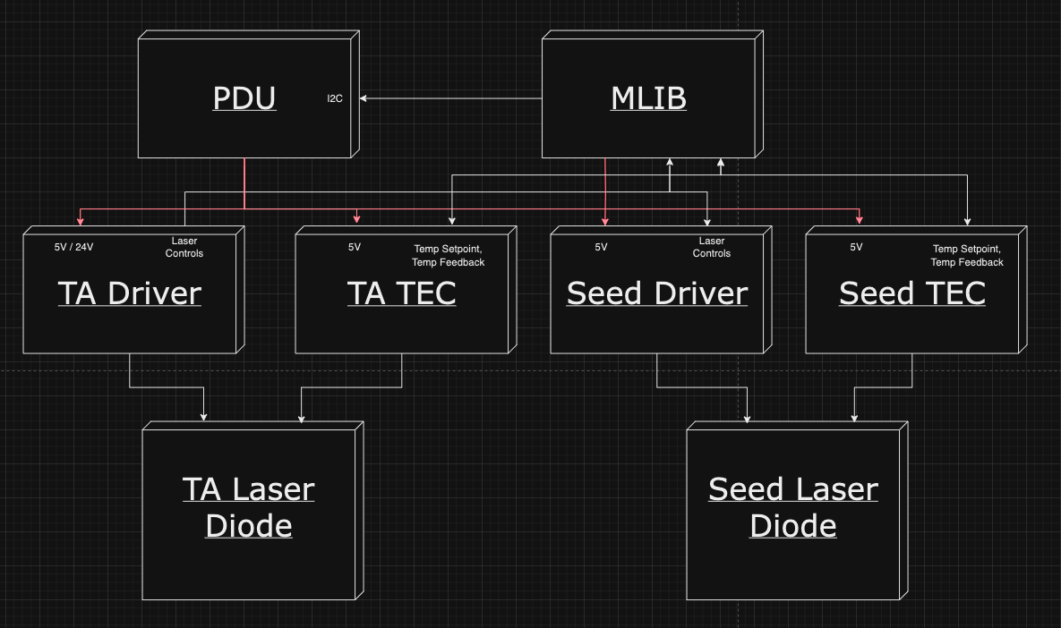

# Parts and Part Numbers

| **Name** | **Part Number** | **Link** |
| --- | --- | --- |
| Seed Laser Diode | FPV785P | <https://punchout.webdev02.thorlabs.com/thorproduct.cfm?partnumber=FPV785P> |
| TA | TPA780P20 | <https://www.thorlabs.com/thorproduct.cfm?partnumber=TPA780P20> |
| Seed Driver | MPL500 | <https://www.teamwavelength.com/product/mpl500-laser-diode-driver/> |
| TA Driver | LD10CHA | <https://www.teamwavelength.com/product/ld10cha-10-a-30-v-laser-diode-driver/> |
| Seed TEC | WTC3293 | <https://www.teamwavelength.com/download/Datasheets/wtc3243.pdf> |
| TA TEC | WTC3293 | <https://www.teamwavelength.com/download/Datasheets/wtc3243.pdf> |

## Component Configurations

### MPL500

The MPL500 runs in constant current mode with the onboard trimpots tuned to offer no offset to MOD_INPUT and to limit the current to the diode at 200mA. Each MPL500 that has its trimpots tuned should have them taped over and signed off on to prevent accidental modification.

The photodiode is not required in this mode and instead of being connected to the MPL500 it is routed directly to the laser safety board. Note that in constant power mode, the photodiode is required.

In normal operation, the ENABLE pin is pulled high and the MOD_INPUT pin is set to 1.5V. This voltage corresponds to 150mA to the seed, or 10mW.

### TA Driver

The LD10CHA runs in constant current mode without a photodiode, similar to the MPL500. It also runs in dual power supply mode with 5V and 24V supplied. It has its trimpots set to add nothing to MOD_INPUT and limit the laser current to 6A.

To enable this configuration, the system should have JP1 and JP2 pulled before beginning operation. JP3 can be removed or not since a photodiode is not connected. The setpoint trimpot may be turned all the way to CCW until a click is heard to zero it, and the limit trimpot may be set to 6A by looking at the CURR_LIM voltage feedback. The switches must be configured for Constant Current.

# Normal Operation

In normal operation, the seed will be turned on at startup and remain on until the system is powered down. When the laser needs to pulse for a scan, the TA is enabled and the TA’s MOD_INPUT is pulsed with a voltage proportional to the intended laser power.

Nominally, the laser system goes through the following steps:

1. Turn on Seed
   1. Set Seed En = 1
   2. Set MOD_INPUT = 1.5V (150mA)
2. Reset Error Registers
3. Enable TA
   1. Set TA ENABLE = 0
4. Pulse TA
   1. Pulse MOD_INPUT at 40Hz, 250us time on, at 5V to get 5A per pulse
5. Disable TA
   1. Set TA_ENABLE = 1
6. Turn off Seed
   1. Set SEED_EN = 0

# Fault List

The laser system has 10 different signals that must be within range in order to allow the TA to be enabled. Those are:

* ESTOP OK
* TA_ENABLE
* Seed Current OK
* Seed Photodiode OK
* TA Current Pulse Length OK
* TA Current Pulse Intensity OK
* TA Current Pulse Frequency OK
* TA Photodiode Pulse Length OK
* TA Photodiode Pulse Intensity OK
* TA Photodiode Pulse Frequency OK

All 10 of these go through a series of AND gates to enable the TA driver. As the TA driver is enabled by a 0V/low signal rather than a high signal, the final AND gate is actually a NAND ​​gate.

Each of these errors has a memory device attached and will hold its state if it trips. A reset is required to reset these memory units. At startup, the system will be in an error state because the seed will be disabled. Once the seed is enabled the system must be reset in order to enable the TA. Alternatively, the threshold may be set such that the TA never turns off due to the activity of the seed and this step may be omitted.

In normal operation, the laser should fire at 40Hz with a pulse width of 250us and a height of 5V. The seed should be given 1.5V.

If the laser breaches 5% of any of these four parameters, the laser system should trip and disable the TA. Documentation about this will be updated here once testing completes.